Experiment no 02

Q1.Write a program to check whether a number is even or odd.

num = int(input("Enter a number: "))
if num % 2 == 0:
print("The number is Even")
else:
print("The number is Odd")

output:
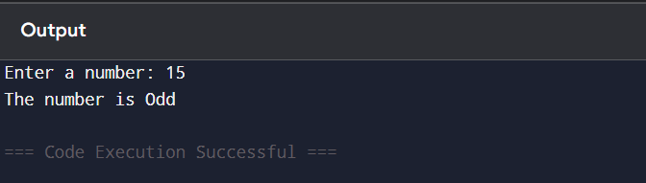

Q 2. Write a program to find the largest of three numbers.

num1 = int(input("Enter first number: "))
num2= int(input("Enter second number: "))
num3 = int(input("Enter third number: "))

if num1 >= num2 and num1 >= num3:
print("Largest number is:", num1)
elif num2 >= num1 and num2 >= num3:
print("Largest number is:", num2)
else:
print("Largest number is:", num3)

output:
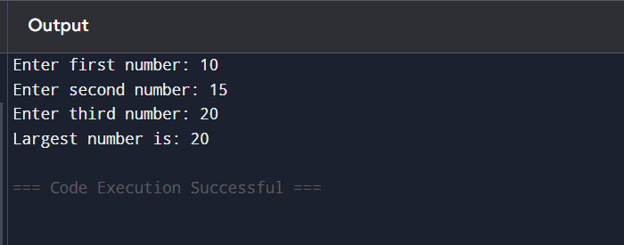

Q3.Write a program to check whether a number is prime

num = int(input("Enter a number: "))
if num > 1:
for i in range(2, num):
if num % i == 0:
print("The number is not Prime")
break
else:
print("The number is Prime")
else:
print("The number is not Prime")

output:
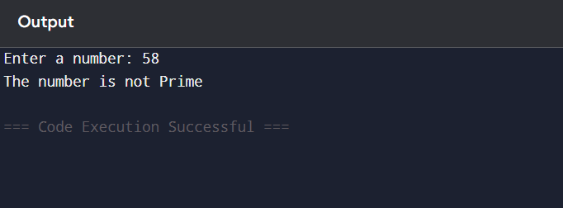
Q4. Write a program to check whether a year is leap year.

year = int(input("Enter a year: "))
if (year % 4 == 0 and year % 100 != 0) or
(year % 400 == 0):
print("It is a Leap Year")
else:
print("It is not a Leap Year")

output:
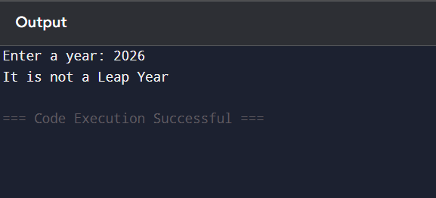

Q5. Write a program to print first n natural numbers using loop.
n = int(input("Enter value of n: "))
for i in range(1, n + 1):
print(i)

output:
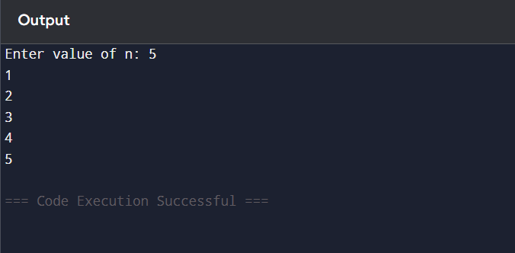

Q6. Write a program to print multiplication table of a given number.
num = int(input("Enter a number: "))
for i in range(1, 11):
print(num, "x", i, "=", num * i)

output:
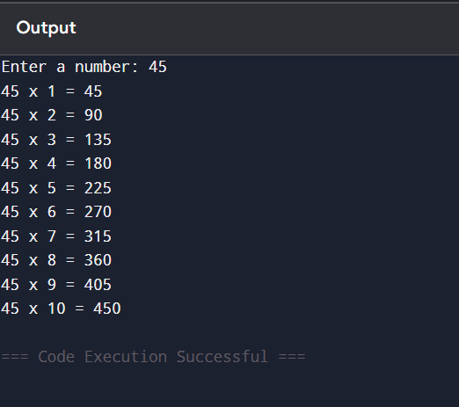
Q7. Write a program to calculate factorial of a number using loop.
num = int(input("Enter a number: "))
factorial = 1
if num < 0:
print("Factorial does not exist for negative numbers")
else:
for i in range(1, num + 1):
factorial *= i
print("Factorial of", num, "is", factorial)

output:
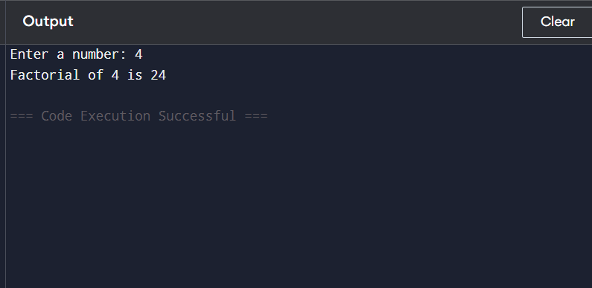
Q8.Write a program to display Fibonacci series.
n = int(input("Enter number of terms: "))
a, b = 0, 1
print("Fibonacci Series:")
for i in range(n):
print(a, end=" ")
a, b = b, a + b
output:
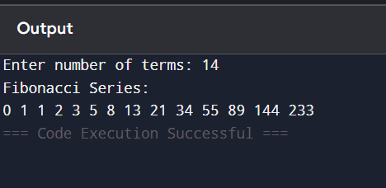
Q9. Write a program to count digits in a number.
num = int(input("Enter a number: "))
num = abs(num)
count = 0

if num == 0:
count = 1
else:
while num > 0:
num = num // 10
count += 1
print("Number of digits:", count)

output:
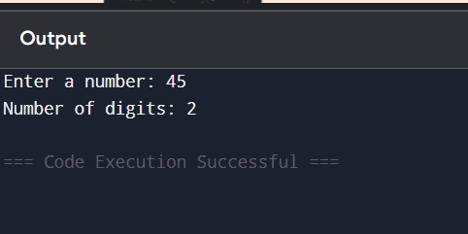
Q10. Write a program to reverse a number.
num = int(input("Enter a number: "))

rev = 0
while num != 0:
digit = num % 10
rev = rev * 10 + digit
num = num // 10

print("Reversed number:", rev)
output:
